This series of power supplies can generate output that ranges from 20kV to 40kV, 2kW and are housed in compact 19” racks to give a highly regulated output. These rugged units are designed for continuous operation
REGULATED HIGH VOLTAGE DC POWER SUPPLY FOR ELECTROSTATIC SEPARATION
30kV/40kV upto 2kW

mainly for electrostatic separation.

Features:
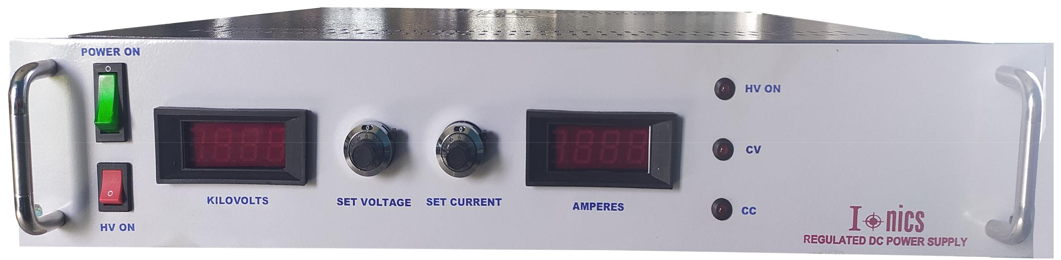
- Precision regulated
- Protected against frequent short circuits & arcs

- 19” rack mountable

[
- OEM customization available

Technical Specifications
PARAMETER | SPECIFICATION
Input Voltage | 230V ±10% A C, 50Hz, single phase
Output Voltage Range* | 30kV / 40kV DC
Output Power Range* | Upto 2kW
Polarity* | Positive / Negative
Line Regulation | ≤ 0.05% for 10% variation in input voltage
Load Regulation | ≤0.1% for 0 to 100% load variation
Stability | Better than 0.01%/hour after 1 hour warm up
Regulation Mode* | Constant voltage – Constant current
Voltage & Current Control* | Local: By 10-turn potentiometers on the front panel  Remote: 0 to 10V DC signals for voltage & current control; OR  Control through computer interface
Protections* | Against over load, over current, over voltage, short-circuit and arc
Remote Controls & Signals  through Pluggable Connector /D-Connector (External RS232 Microcontroller Module) * | 10V DC reference  10V DC HV enable signal  0 to 10V DC signal for voltage & current control  0 to 10V DC signal for voltage & current monitoring
Front Panel | AC power ON/OFF switch with indication  HV ON/OFF switch with indication  3½ digit voltage and current meters  10-turn potentiometers for voltage and current control  Constant voltage – constant current mode indication
Back Panel | Socket for mains input with 250V, 10A 3 conductor power cord of 1.5 meters  Fuse holder with fuse  Terminal for HV output with 10ft of detachable high voltage cable  Stud for grounding the unit  Remote interface connector*
Topology | High frequency resonant / PWM-controlled switch mode
Switching Device | IGBT
Cabinet | 2U/3U, 19” rack, powder coated
*Optional. To be specified by the user.
#RS232 interface available at an extra cost.

Remote Interface Connector Configuration
 | Analog Interface | Digital Interface
Pins | 28 Pin Pluggable Connector | 25 Pin D Connector
1 | Earth | Earth
2 | Common | Common
3 | Interlock | HV Enable
4 | HV Enable | Voltage Control Remote
5 | Reference | Current Control Remote
6 | Common | Over Voltage Control Remote*
7 | Voltage Control Remote | Over Current Control Remote*
8 | Voltage Control Local | Common
9 | Common | Voltage Monitor
10 | Current Control Remote | Current Monitor
11 | Current Control Local | Reserved Monitor*
12 | Common | Reserved Monitor*
13 | Voltage Monitor | Common
14 | Current Monitor | Mode Status
15 | Common* | Interlock Status
16 | Voltage Mode Status* | HV ON Status
17 | Current Mode Status* | Common
18 | HV ON Status* | PS Fault Status*
19 | Common* | Over Voltage Status*
20 | PS Fault Status* | Over Current Status*
21 | Over Voltage Status* | Over Temperature Status*
22 | Over Current Status* | Open Circuit Status*
23 | Over Temperature Status* | Phase Failure Status*
24 | Open Circuit Status* | Reserved Status*
25 | Phase Failure Status* | Common
26 | Common*
27 | Over Voltage Control*
28 | Over Current Control*
Ordering  Code | HV | 040 | K | 600 | W | N | C | I | D | 5 | T
 |  | 1 |  | 2 |  | 3 |  |  |  | 5 | 6
Section | Description |  |  | Options |  | Options Description
1 | Output Voltage |  |  | XXX |  | Value of output voltage
2 | Output Power |  |  | Y |  | Value of output power
3 | Polarity |  |  | P |  | Positive
 |  |  |  | N |  | Negative
4 | Short Circuit |  |  | A |  | Shut down
 |  |  |  | B |  | Shut down & manual reset
 |  |  |  | C |  | Shut down & automatic restart
 |  |  |  | D |  | Constant current
5 | Regulation Mode |  |  | 4 |  | Constant voltage
 |  |  |  | 5 |  | Constant voltage & constant current
6 | Control Mode |  |  | L |  | Local control
 |  |  |  | R |  | Remote control through D-connector
 |  |  |  | T |  | Remote control through pluggable connector

*Optional. To be specified by the user only as per application’s requirement.

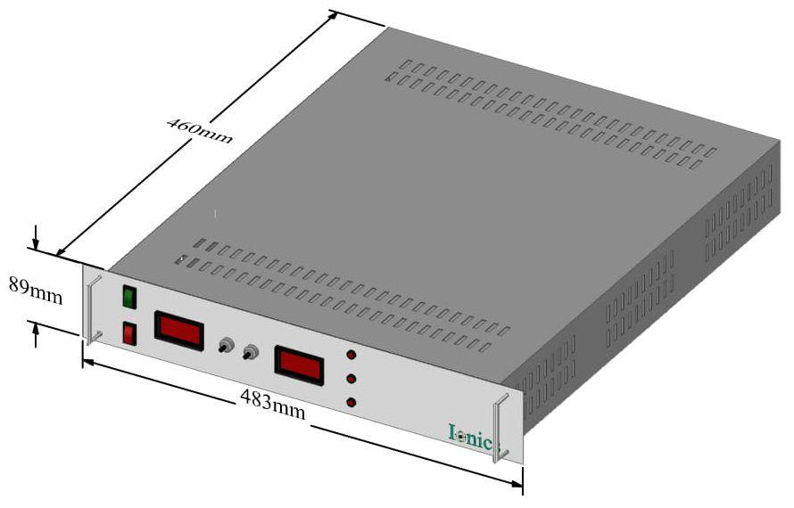

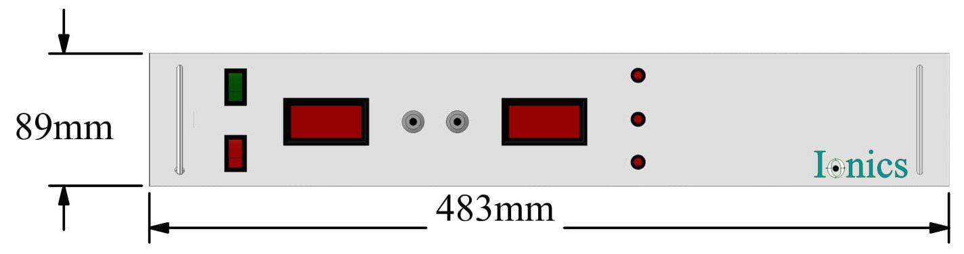

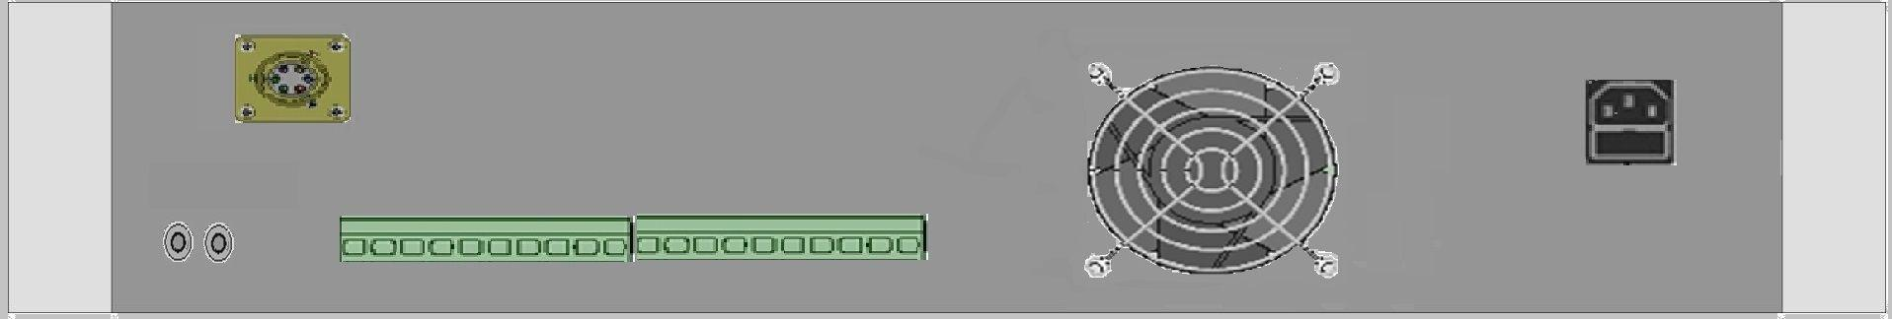

For any queries or customization requests contact us at info@ionics.co.in
For product line information visit us at www.ionics.co.in

